PHYS1110D – Engineering Physics: Mechanics and Thermodynamics

Tutorial Problems for Week 9: Rotation and Angular Momentum

*Note: The moment of inertia of a uniform rod (mass $m$, length $l$) with respect to an axis through its center and perpendicular to it is $I={ml^{2}}/{12}$.*

**Problem 1 – Center of Mass**

Two blocks A (mass $m_{A}=3.0 \text{kg}$) and B (mass $m_{B}=2.0 \text{kg}$) are tied to a rope hanging over through two frictionless pulleys. There is also no friction between the rope and the pulleys. The blocks are moving due to the downward gravity force (acceleration due to gravity $g=9.8 \text{m/}{\text{s}}^{\text{2}}$). Neglecting the mass of the pulleys and the rope, please find the *total* force $F$ (including magnitude and direction) exerted by the two pulleys on the rope.

**Solution:**

Let the magnitude of the acceleration of A (and B) be $a$, and the tension in the string be $T$. For A and B as a whole, the center of mass does not move horizontally, so $F$ cannot have a horizontal component; in the vertical direction (positive: downward):

$$\left(m_{A}+m_{B}\right)g-F=\left(m_{A}+m_{B}\right)\frac{d^{2}}{dt^{2}}\left(\frac{m_{A}y_{A}+m_{B}y_{B}}{m_{A}+m_{B}}\right)=m_{A}a-m_{B}a$$

But what is $a$? By dealing with A and B separately:

$$m_{A}a=m_{A}g-T, m_{B}\left(-a\right)=m_{B}g-T$$

Eliminating $T$, we find

$$a=\frac{m_{A}-m_{B}}{m_{A}+m_{B}}g$$

Then

$$\begin{aligned}\begin{aligned}F\end{aligned}&=\left(m_{A}+m_{B}\right)g-\left(m_{A}-m_{B}\right)a \\ &=\frac{4m_{A}m_{B}}{m_{A}+m_{B}}g=\frac{4×3.0 \text{kg}×2.0 \text{kg}}{\left(3.0+2.0\right)\text{ kg}}×9.8 \text{kg∙m/}{\text{s}}^{\text{2}}=47.0 \text{N}\end{aligned}$$

Pointing upwards.

*Remark:* You can also find $a$ from the conservation of mechanical energy in this problem. Let the initial position of A and B corresponds to zero potential energy. Then the energy as a function of *downward* displacement $h\left(t\right)$ of A is

$$E\left(t\right)=\frac{1}{2}\left(m_{A}+m_{B}\right){\left(\frac{dh}{dt}\right)}^{2}-m_{A}gh\left(t\right)+m_{B}gh\left(t\right)=0$$

Take the time derivative of both sides (you need to use the chain rule):

$$\left(m_{A}+m_{B}\right)\frac{d^{2}h}{dt^{2}}\frac{dh}{dt}-\left(m_{A}-m_{B}\right)g\frac{dh}{dt}=0$$

Crossing out the velocity ${dh}/{dt}$, we obtain the acceleration:

$$a=\frac{d^{2}h}{dt^{2}}=\frac{m_{A}-m_{B}}{m_{A}+m_{B}}g$$

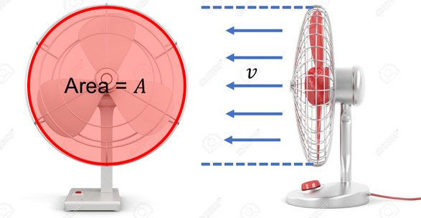**Problem 2 – Impulse, Momentum and Force**

A fan is inhaling air (initial velocity is zero) and blowing it out at constant velocity $v$ towards its front (see the figure). The density of the air is $ρ$ (treating it as a constant). What is the extra pressure (force per unit area) exerted by the air on the fan leaves? (By *extra* we mean that the atmosphere pressure should be deducted.)

**Solution:**

Let the cross section of the fan be $A$. We consider the amount of air blown out by the fan during a short time period $dt$. Then its mass is $dm=ρ\left(Av dt\right)$. The initial velocity of the air is zero, and it gain a final velocity of $v$. So, its momentum change is

$$dp=dm×v=ρAv^{2} dt$$

The force per unit area (pressure) on the fan is therefore

$$P=\frac{1}{A}\frac{dp}{dt}=ρv^{2}$$

**Problem 3 – Collision Revisited**

*(This is a classical problem examining your understanding of introductory mechanics. Make good use of conserved quantities in the system.)*

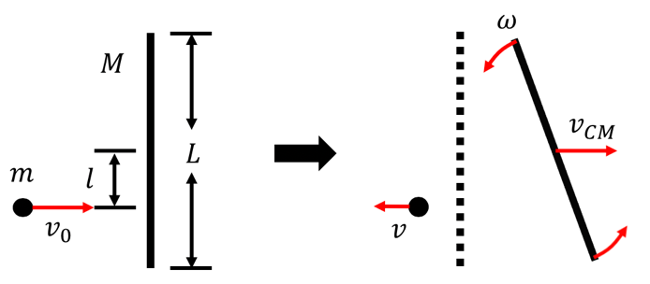

A uniform rod (mass $M$, length $L$) is at rest on a frictionless horizontal plane. A small ball of mass $m$ with initial velocity $v_{0}$ towards right hits the rod at distance $l=L/6$ to the rod center (see the figure). No energy is lost in the collision. As a result, the rod starts moving to the right, and rotating around its center. Please find the following quantities after the collision:

1. The velocity $v$ of the ball;
2. The velocity $v_{CM}$ of the center of mass (CM) of the rod;
3. The angular velocity $ω$ of the rotation of the rod around its center.

**Solution:**

We write down all the conserved quantities of the system.

* Energy
$$\frac{1}{2}mv_{0}^{2}=\frac{1}{2}mv^{2}+\left(\frac{1}{2}Mv_{CM}^{2}+\frac{1}{2}Iω^{2}\right) \left(I=\frac{1}{12}ML^{2}\right)$$

* Momentum (the useful component is along the $x$-direction)

$$mv_{0}=mv+Mv_{CM}$$

*(Although we draw $v$ in the $\left(-x\right)$-direction, we write $mv$. If the answer turns out to be negative, then our drawing is correct.)*

* Angular momentum (*Coordinate origin is chosen at where the rod center was before collision*. The useful component is along the $z$-direction; angular momentum of the rod center of mass is zero)

$$mv_{0}\frac{L}{6}=mv\frac{L}{6}+Iω$$

We now have enough equations to solve for $v, v_{CM}$ and $ω$. The answers are

$$v=\frac{4m-3M}{4m+3M}v_{0}, v_{CM}=\frac{6m}{4m+3M}v_{0}, ω=\frac{12m}{4m+3M}\frac{v_{0}}{L}$$

*Remark: When solving problems related to rotations, you should be very careful about the choice of the coordinate origin. If you are sloppy on this issue, you are likely to derive ridiculous results.*

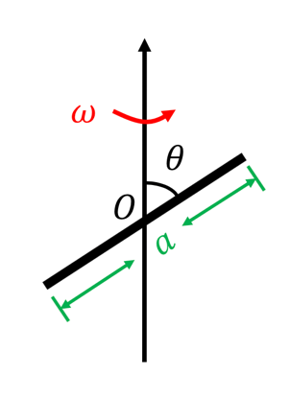**Problem 4 – Direction of the Angular Momentum**

The angular velocity of a rotating body is along the rotation axis, but this is *not* true for the angular momentum, as you can show in this problem.

Consider a uniform rod (mass $m$, length $a$, negligible thickness) rotating at angular velocity $ω$ about an axis through its center (chosen as the coordinate origin). However, the angle between the rod and the axis is some acute angle $θ<90°$ (see the figure). Please find:

1. The moment of inertia of the rod $I$ around the axis;
2. The angular momentum vector of the rod $L$ as a function of time.

**Solution:**

1. By definition, you can easily obtain
$$I=\frac{1}{12}ma^{2}\sin^{2}{θ}=I_{0}\sin^{2}{θ}$$

2. 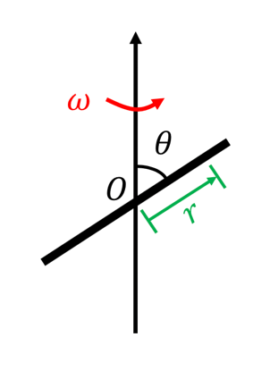We first find the angular momentum of a small line segment of length $dr$, at distance $r$ (with a slight abuse of notations) from the origin. (If $r<0$, then this segment is to the left of the rod). Suppose that at $t=0$, the rod is in the $xz$-plane. After time $t$, the rod has rotated an angle $φ\left(t\right)=ωt$. So, the position of this line segment is at

$$r=\left(r\sin{θ}\cos{ωt}, r\sin{θ}\sin{ωt}, r\cos{θ}\right)$$

(as you can see in the spherical coordinates). The velocity is

$$v=\frac{dr}{dt}=\left(-ωr\sin{θ}\sin{ωt}, ωr\sin{θ}\cos{ωt}, 0\right)$$

You can obtain this result geometrically or using the chain rule of differentiation. The mass of this line segment is (we use the letter $d$ to remind us that we are dealing with something that we will make it tend to zero)

$$dm=\frac{m}{a}dr$$

The angular momentum of this small segment is

$$dL=r×\left(dm\right)v=\frac{m}{a}dr×\frac{ωr^{2}}{2}\left(-\sin{2θ}\cos{ωt}, -\sin{2θ}\sin{ωt}, 1-\cos{2θ}\right)$$

Finally, since mass is distributed continuously on the rod, we replace the sum by integration:

$$\begin{aligned}L=\int_{\text{rod}}{dL}&=\int_{-a/2}^{a/2}{r^{2}dr×\frac{mω}{2a}\left(-\sin{2θ}\cos{ωt}, -\sin{2θ}\sin{ωt}, 1-\cos{2θ}\right)} \\ &=\frac{ma^{2}}{12}ω×\frac{1}{2}\left(-\sin{2θ}\cos{ωt}, -\sin{2θ}\sin{ωt}, 1-\cos{2θ}\right) \\ &=I_{0}ω×\frac{1}{2}\left(-\sin{2θ}\cos{ωt}, -\sin{2θ}\sin{ωt}, 1-\cos{2θ}\right)\end{aligned}$$

Here we used $I_{0}={ma^{2}}/{12}$. We see that $L$ is definitely *not* in the same direction as the angular velocity vector for all $θ<90°$.

*Remark:* For $θ=90°$, we obtain the result

$$L=I_{0}ω×\frac{1}{2}\left(0, 0, 2\right)=I_{0}ω$$

We warn you that this *vector* equation is generally *not* true.

**Problem 5 – Kepler’s Second Law and Conservation of Angular Momentum**

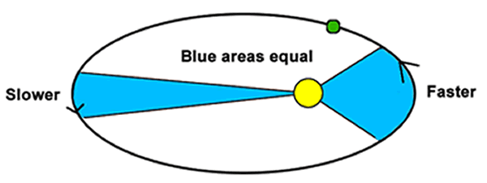

In high school, you may have heard about Kepler’s Second Law of planetary motion:

*A line segment joining a planet and the Sun sweeps out equal areas during equal intervals of time.*

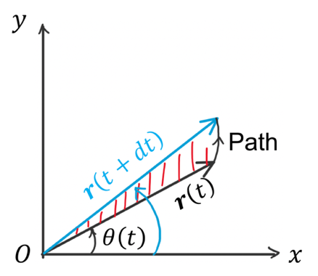The area swept per unit time by this line segment is called the **areal velocity**. We now show that *this law is a direct consequence of the conservation of angular momentum*.

To set up the stage, we put the Sun at the origin of our coordinate system. The mass of the sun is so large compared to the planet, that its position can be regarded as fixed. Let the plane in which the planet is moving be the $xy$-plane. The position of the planet at time $t$ is given by the vector $r\left(t\right)$. The area swept by $r\left(t\right)$ in the interval $\left[t, t+dt\right]$ is denoted by $dA$

1. Prove that (up to terms proportional to $dt$)

$$dA=\frac{1}{2}\left(x\left(t\right)v_{y}\left(t\right)-y\left(t\right)v_{x}\left(t\right)\right)dt$$

*Hint: For any “reasonable” function $f\left(t\right)$ of time, we can write for small $dt$*

$$f\left(t+dt\right)=f\left(t\right)+\frac{df}{dt}\left(t\right) dt$$

1. What is the relationship between the areal velocity ${dA}/{dt}$ and the angular momentum of the planet? (let the mass of the planet be $m$);
2. Why is the angular momentum of the planet conserved? Then show that Kepler’s Second Law follows immediately.

**Solution:**

1. This problem can be solved quickly using the determinant:
$$\begin{aligned}dA&=\frac{1}{2}\det\left(\begin{matrix}x\left(t\right) & x\left(t+dt\right) \\ y\left(t\right) & y\left(t+dt\right)\end{matrix}\right)=\frac{1}{2}\det\left(\begin{matrix}x\left(t\right) & x\left(t\right)+v_{x}\left(t\right)dt \\ y\left(t\right) & y\left(t\right)+v_{y}\left(t\right)dt\end{matrix}\right) \\ &=\frac{1}{2}\left(x\left(t\right)\left(y\left(t\right)+v_{y}\left(t\right)dt\right)-y\left(t\right)\left(x\left(t\right)+v_{x}\left(t\right)dt\right)\right)=\frac{1}{2}\left(x\left(t\right)v_{y}\left(t\right)-y\left(t\right)v_{x}\left(t\right)\right)dt\end{aligned}$$

2. Recall that

$$L=r×mv=m\left(\begin{matrix}yv_{z}-zv_{y} \\ zv_{x}-xv_{z} \\ xv_{y}-yv_{x}\end{matrix}\right)$$

If we choose the plane in which the planet is moving as the $xy$-plane, then $v_{z}=0, z=0$ all the time, and the $L$ vector reduces to

$$L=m\left(xv_{y}-yv_{x}\right)e_{z}$$

This $z$-component is the same as $2m$ times the areal velocity:

$$L_{z}=2m\frac{dA}{dt}$$

1. The only force on the planet is the gravitational force pointing from the planet to the sun. Since we choose the origin to be at the sun, this force does not produce any torque. Thus, the angular momentum of the planet must be a constant.

From the conclusion of question 2, this leads to a constant areal velocity, which is exactly Kepler’s Second Law.